**8.1 Group Psychology\***

Social Action

* Actions and behavior that individuals are conscious of and performing because others are around
* Social action (individual) vs social interaction (more than 2 individuals)

1. Social facilitation (remember Yerkes-Dodson law raising arousal)
   1. Describes the tendency of people to perform at a different level based on the fact that others are around
   2. **Do better at familiar tasks, and worse at unfamiliar tasks when others are around**
2. Deindividuation
   1. **A loss of self-awareness in large groups** (which provide anonymity), which can lead to drastic changes in behavior
3. Bystander effect
   1. Describes the observation that when in a group, **individuals are less likely to respond to a person in need**
   2. Because in groups, 1) we are less likely to notice danger, and 2) we take cues from each other
   3. Depends on 1) the degree of emergency, 2) responsibility of bystander e.g. competency, and 3) cohesiveness of the group e.g. whether the bystanders are well-acquainted
4. Social loafing
   1. Individuals tend to put in **less effort when in a group** setting than individually
5. Peer pressure
   1. Refers to the social influence placed on individuals by **others they consider equal**

Group Processes

* Look at social interaction

1. Group polarization
   1. Tendency toward making decisions in a group that are **more extreme** than the thoughts of the individual group members
      1. Risky shift (toward risk)
      2. Choice shift (toward caution)
2. Groupthink
   1. Tendency for groups to make decisions based on ideas and solutions that arise **within the group without considering outside ideas**
   2. Eight factors indicative of groupthink
      1. Illusion of invulnerability (the creation of optimism and encouragement of risk-taking)
      2. Collective rationalization (ignoring warnings against the ideas of the group)
      3. Illusion of morality (the belief that the group’s decisions are morally correct)
      4. Excessive stereotyping (the construction of stereotypes against outside opinions)
      5. Pressure for conformity
      6. Self-censorship
      7. Mindguards (the appointment of members to the role of protecting against opposing views)

Culture

* Describes the beliefs, ideas, behaviors, actions and characteristics of a group or society of people

1. Assimilation
   1. The process by which a group or individual’s culture begins to **melt into another culture**
2. Multiculturalism
   1. Refers to the encouragement of **multiple cultures** within a community to enhance diversity
3. Subcultures
   1. Refer to a group of people within a culture that **distinguish** themselves from the primary culture to which they belong

**8.2 Socialization\***

* Process of developing and spreading norms, customs and beliefs
* Categorizations
  + Primary socialization
    - Occurs during childhood, through parents
  + Secondary socialization
    - Learning from within smaller sections of the larger society
  + Anticipatory socialization
    - Prepares for future changes in occupations, living situations, or relationships
  + Resocialization
    - Discards old behaviors in favor of new ones to make a life change

Norms

* Determine the boundaries of acceptable behavior within society

1. Folkway - nice to do, nothing bad if don't (hold the door open for someone else)
2. Mores - should do, slight negative if don't (being a liar/cheating)
3. Laws - should follow, there are formal consequences/ sanctions if you don't (stealing)
4. Taboo - worst of them all, severely looked down upon and may be punishable by law (incest)

Agents of Socialization

* Family, peers, school, religious affiliation, and other groups that promote socialization

Stigma

* The extreme disapproval or dislike of a person or group based on perceived differences from the rest of society
* Linked to **labelling theory** → labels given to people affect not only how others respond to that person, but also the person’s self-image → deviant individual behavior becomes even **more deviant** when a person is negatively labeled or classified as such

Deviance

* Refers to any **violation** of norms, rules, or expectations within a society
* Differential association theory
  + Deviance can be **learned** through interactions with others (who are also deviant)
* Strain theory
  + Explains deviance as a natural reaction to the **disconnect between social goals and social structure**
  + E.g. Deviant behavior such as theft may arise as an attempt to achieve the social goal (american dream) outside of the limiting social structure (inability to guarantee education and opportunity)

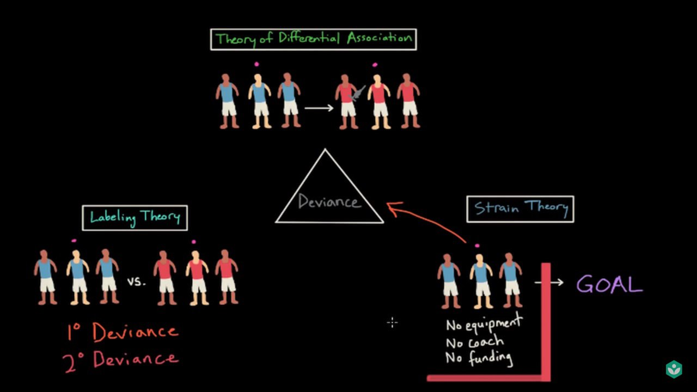

Conformity

* Changing beliefs or behaviors in order to fit into a group or society

1. Normative conformity
   1. **The desire to fit into a group** because of fear of rejection
2. Internalization
   1. Involves changing one’s behavior to fit with a group while also **privately agreeing with the ideas of the group**
3. Identification
   1. **Outward acceptance** of others’ ideas **without personally taking on these ideas**

Compliance

* A change in behavior based on the request of others (who typically do not have actual power e.g. classmates)

1. Foot-in-the-door technique
   1. Small request → larger request (if small request gained compliance)
2. Door-in-the-face technique
   1. Large request → small request (if large request is refused)
3. Lowball technique
   1. Get an initial commitment → but later discover there are more commitments
4. That’s-not-all technique
   1. Make an offer → then tempt with a better offer (subject to conditions) before a decision is made

Obedience

* A change in behavior based on a command from someone seen as an **authoritative** figure e.g. teacher

**8.3 Attitudes and Behavior\***

* Attitude = the expression of positive or negative feelings toward a person, place, thing, or scenario

Components of Attitudes (ABC)

1. **Affective**
2. **Behavioral**
3. **Cognitive**

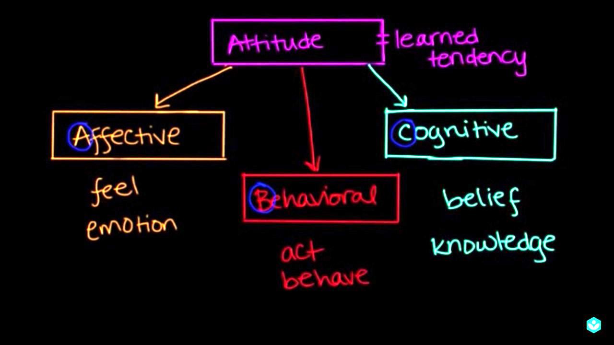

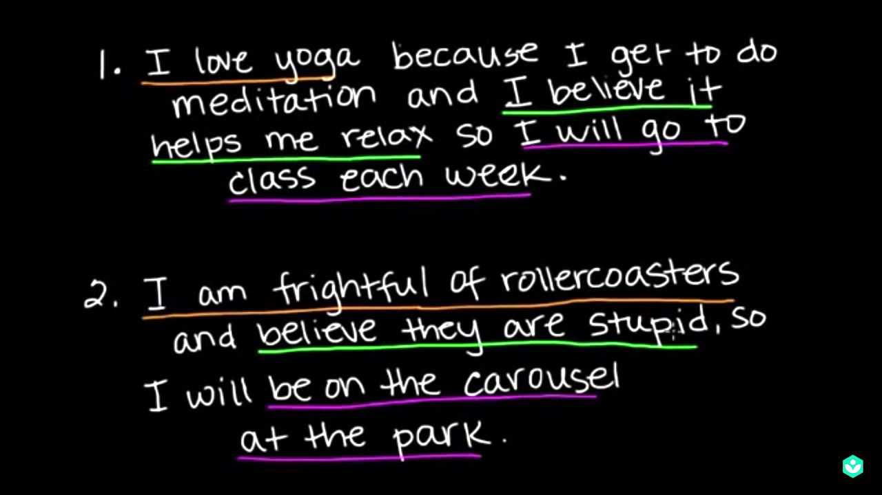

Theories of Attitudes

1. Functional attitudes theory: states that attitudes serve four functions
   1. Knowledge
      1. Provides consistency and stability
         1. Provides organization to thoughts and experiences
         2. Knowing the attitudes of others helps to predict their behavior
      2. E.g. one would predict that an individual who cares about political action to vote in an upcoming election
   2. Ego-expressive
      1. Allows us to communicate and solidify our self-identity
      2. E.g. if a person strongly identifies with a sports team, she may wear a hat that helps her identify as a fan of that team
   3. Adaptive
      1. The idea that one will be accepted if socially accepted attitudes are expressed
   4. Ego-defensive
      1. If attitudes protect our self-esteem or justify actions that we know are wrong
      2. E.g. a child who has difficulty doing math may develop a negative attitude toward the subject
2. Learning theory: posits that attitudes are developed through different forms of learning
   1. Direct contact
      1. E.g. positive attitude toward sweets after tasting them
   2. Direct interaction
      1. E.g. Positive attitude toward smoking if his friends all smoke
   3. Direct instruction
      1. E.g. Negative attitude toward swearing because parents say it is bad
   4. Conditioning
      1. Classical conditioning, operant conditioning, or observational conditioning
3. **Elaboration likelihood model**: states that attitudes are formed and changed through different routes of information processing based on the degree of elaboration
   1. Central route processing
      1. Deep thinking, a lot of elaboration
   2. Peripheral route processing
      1. Do not elaborate, focus on superficial details e.g. appearance of the person delivering the argument, catchphrases and slogans, and credibility
4. Social cognitive theory: states that attitudes are formed through **observation of behavior, personal factors, and environment**
   1. Bandura’s triadic reciprocal causation: behavior, personal factors, and environment

